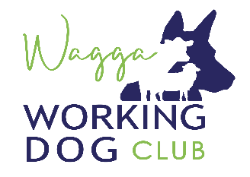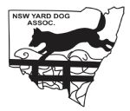
2022 Southern NSW Yard Dog Championship
Affiliated with NSW Yard Dog Assoc. Inc.

Sunday, 27th March 2022
Judges talk 7.00 am for a 7.30 am start.

TRIAL ENTRIES CLOSE- 16th March 2022

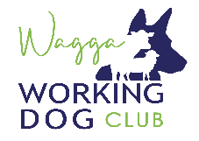
Wagga Working Dog Club 2022 Southern NSW Yard Dog Championships

SUNDAY - All Events
Open/Improver, Novice/Maiden, Encourage

Euberta Hall

DIRECTIONS: Take Olympic Hwy heading north from Wagga Wagga, cross the Murrumbidgee river then turn left onto Old Narranderra Rd, follow for 15kms, watch for signs.

Enquiries: Matt Whitley 0427 362 092
Simon Hartwich 0409 172 075

BREAKFAST, LUNCH AND REFRESHMENTS AVAILABLE
Camping available for free with good amenities (No powered sites).
Yard Trial Entry Form
Dog’s Name | Open $15 | Improver $12 | Novice $10 | Maiden  $8 | Encourage $5

TOTAL FEES ENCLOSED $_________________

Payment must accompany the entry form. All fees include GST.
Cheques made payable to WAGGA YARD DOG CLUB.
No Novice dogs in Improver or Open.
The committee reserves the right to enforce a cut off score if necessary.
No bitches in oestrus permitted on ground.

I enter at my own risk: Entries to: Simon Hartwich
PO Box 226
Name………………………………………….…....... Holbrook NSW 2644

Address……………..……………………………...... simon@waggadogauction.com.au
Ph: 0409 172 075
…………………………………………………….......
Entries close 16th March 2022
Phone………………………………………….….. ... Direct Bank Deposit:
Account Name: Wagga Yard Dog Club
BSB: 325-185 Acct No: 387 002 63
Reference: Trialer’s Name

Email: ……………………………………………........

Signature………………………….............................

Member of NSWYDA Yes / No Member No. __________ (if known)

